H.T No
Regulations:
A17

Sreenidhi Institute of Science and Technology
(An Autonomous Institution)
Code No: 6W104 Date: 22-June-2019 (FN)

M.Tech I-Year I-Semester External Examination, June - 2019 (Supplementary)
ADVANCED MECHANICS OF SOLIDS (CAD/CAM)

Time: 3 Hours Max.Marks:75

Note: a) No additional answer sheets will be provided.
b) All sub-parts of a question must be answered at one place only, otherwise it will not be valued.
c) Missing data can be assumed suitably.

Part - A Max.Marks:25

Answer all QUESTIONS.

1. | State castigliano’s Second theorem. | [3M]
2. | Define and state the significance of shear center. | [3M]
3. | State the limitations of curved beam theory. | [3M]
4. | State and explain Saint-venant’s semi inverse method. | [3M]
5. | State and explain the significance of secant and Johnson’s formulae. | [3M]
6. | What is the stress concentration and explain its effects on flaws? | [2M]
7. | What are the various stresses associated with chain links? | [2M]
8. | State and explain the importance of Winkler back formula. | [2M]
9. | What are the effects of material properties on fracture? | [2M]
10. | What is the importance of J-Integral in fracture mechanics? | [2M]
Part – B Max.Marks:50
ANSWER ANY FIVE QUESTIONS. EACH QUESTION CARRIES 10 MARKS.

11. | a) | State and Derive Maxwell- Betti- Rayleigh reciprocal Theorem | [5M]
 | b) | Derive the expression for stress in a chain link. | [5M]
12. | a) | Define bending axis, Shear center and shear flow. | [5M]
 | b) | Determine the location of the shear center of the section shown in the figure 1 below  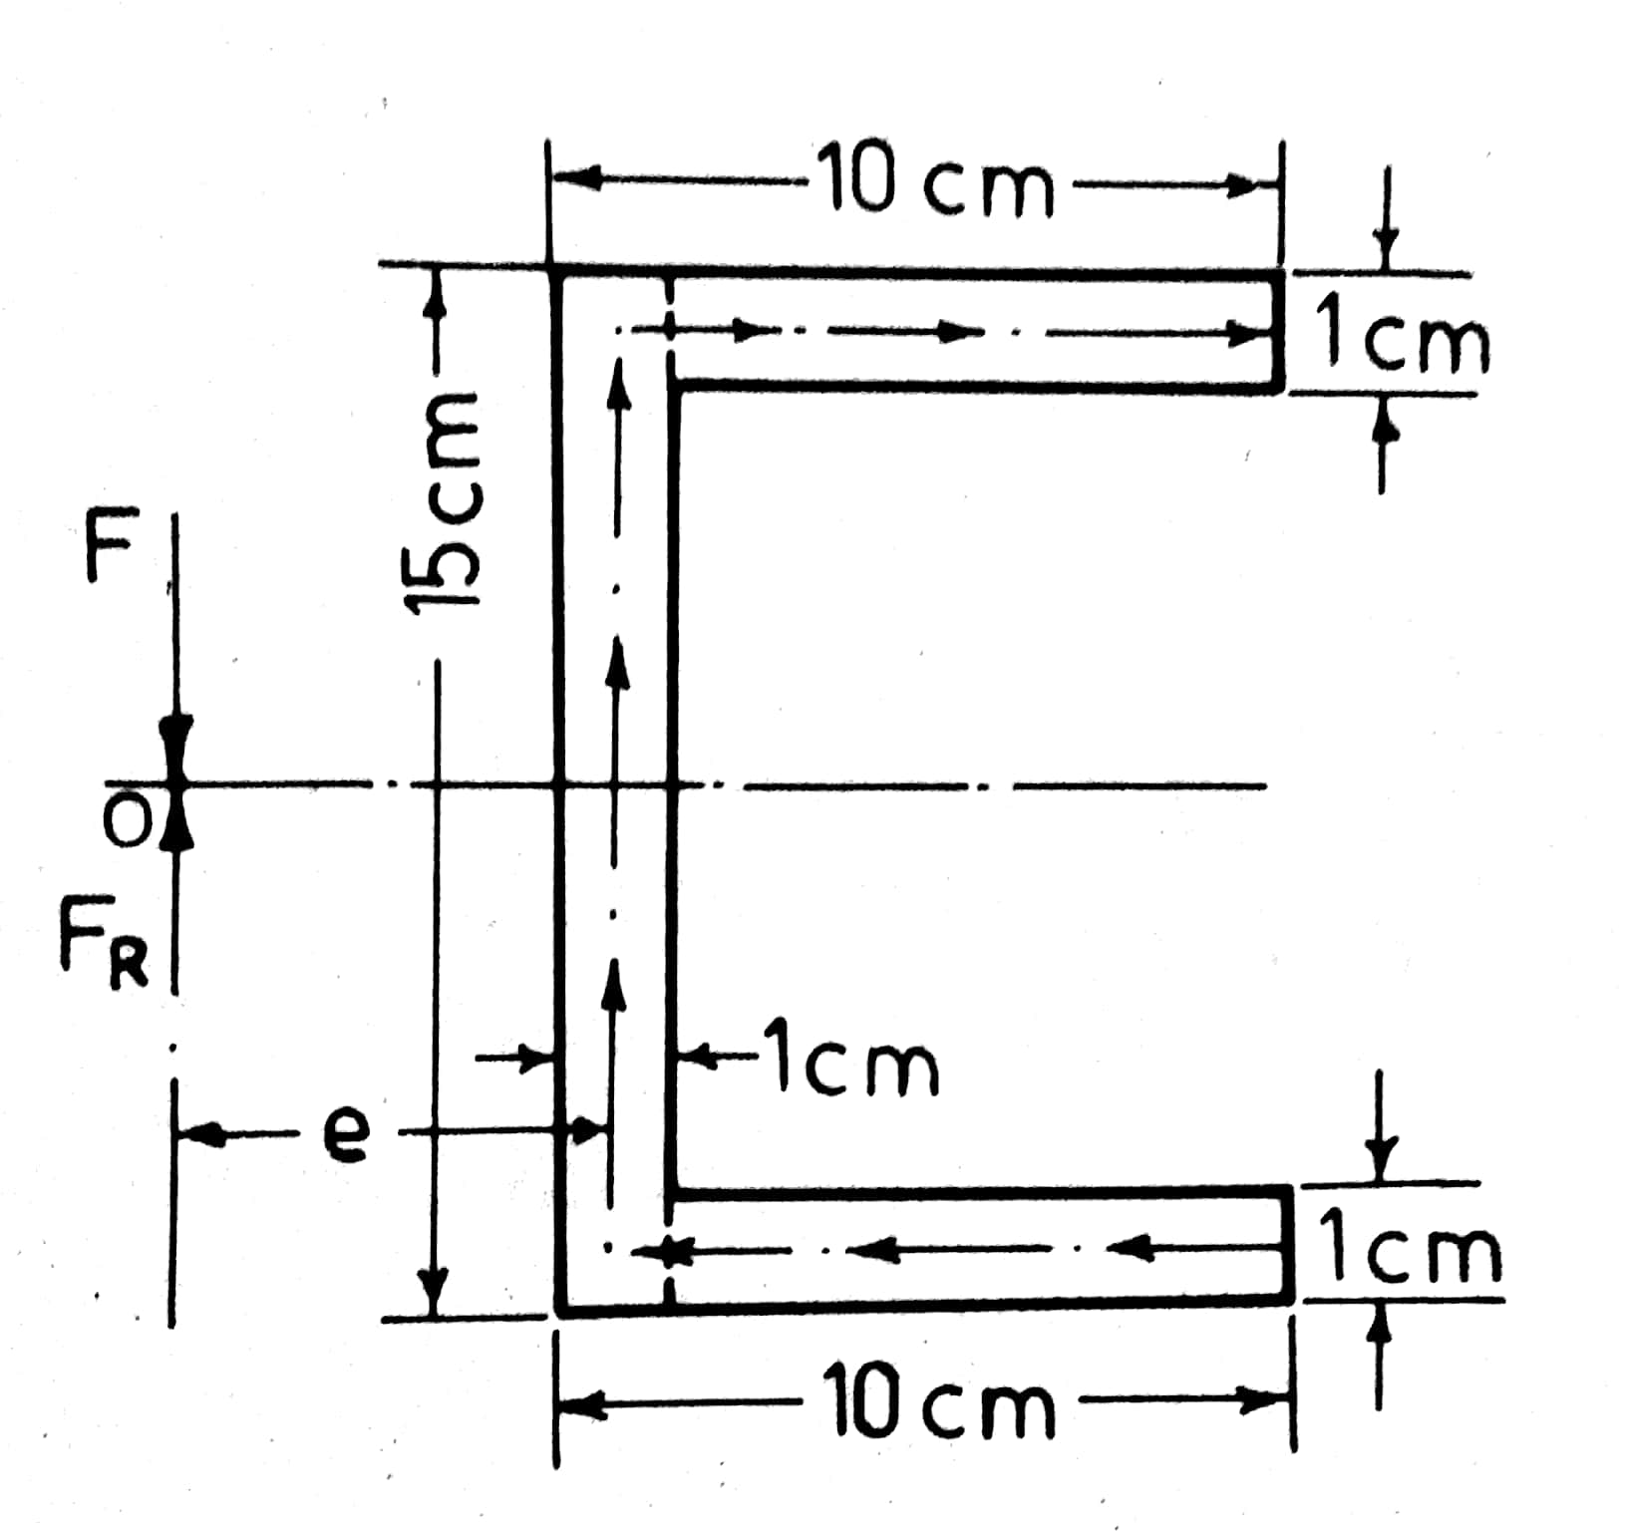  Figure 1 | [5M]
13. | a) | Derive expression for contact stresses of two spheres in contact | [5M]
 | b) | A chain link is subjected to a pull of 15KN. It is composed of steel 2cm diameter and has a mean radius of 2.5 cm . its semi circular ends are connected by straight piece s 2.5cm long . Estimate the maximum compressive stress in the link and the tensile stress at the same section. | [5M]
14. | a) | Derive the equation for torsion of a bar of circular cross section using Prandtl’s method. Also find the components of stress and resultant stress. | [5M]
 | b) | Derive the equation for torsion equation for a thin walled hollow circular rod subjected to a torque T.Also state the assumptions used in the derivation. | [5M]
15. | a) | State the assumptions of Euler’s theory of buckling of columns and derive expression for Euler stress for a column for a column hinged at both ends. | [5M]
 | b) | Find the Euler’s crushing load for a hollow cylindrical cast iron column 15cm external diameter and 2cm thick if it is 6m long and hinged at both ends. E= 80GPa. | [5M]
16. | a) | Differentiate between plane stress and plane strain. | [5M]
 | b) | A rotating disc with a bore radius “c” and an outer radius “b”has a small radius crack of length “a” at the bore. Determine the critical speed for the disk based on i. Yield Stress ii. Critical Stress intensity factor. | [5M]
17. | a) | State and Explain fictitious load method. | [3M]
 | b) | State and explain the theorem of stationary potential energy. | [3M]
 | c) | What are the various fracture modes .Explain? | [4M]

-- 00 -- 00 –

